Project: Neiafu Tonga Temple
Job Number: W1134
Contractual Completion Date: May 20, 2025
Projected Substantial Completion Date: December 10, 2025

Days Behind Schedule: 204 Days

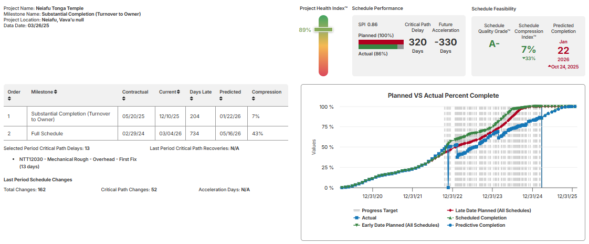

Successes:
The catwalks and ladders were delivered and installed in the maintenance access spaces.

Schedule Gain / Loss Since The Last Update: 55 Day Loss
We lost 55 days since our last update. This is due to two separate issues. First the ongoing delay completing HVAC due to missing materials and inadequate crews and capabilities is ow pushing the completion of mechanical rough and subsequent finishes in the baptistry and Area 3. This issues accounts for 23 days of the current 55 day slip. The additional 32 days are the result of the pending change adding intumescent paint to the millwork in select rooms throughout the temple. The scope is essentially identical to the changes in Samoa. However, because we are so far behind them in starting finishes we will be applying the intumescent paint along with the other painting activities. This should allow the intumescent paint to be applied and cured before any decorative paint or gold leaf are applied. So, the impact to the project schedule is not as dramatic in Neiafu. You will note that with the current logic the intumescent paint does not hit the critical path until finishes are under way in Are 4. Please carefully review the added activities and sequencing to ensure we have properly captured the added scope and how it will be performed along the original work. I am not the process is fully outlined.

We are still struggling to complete the mechanical systems at the mezzanine and connecting critical systems needed to climatize the building. The rework and seismic bracing issues delayed progress throughout the Temple. As noted previously, we essentially started over on HVAC and plumbing rough ins. This has been a significant setback.

If I remove the delay to the Baptistry and Area 3 ductwork we revert back to our previous delay. Meaning mechanical rough on the mezzanine level is still driving the critical path through the temple and is falling further behind. In that scenario the longest critical path shifts and the new intumescent painting activities through Are 1 all become critical.

Several other trades are also delaying work in the temple and on the Ancillary Building. As noted previously, to improve the schedule it will come down to finding additional qualified manpower to allow concurrent work on mechanical rough Areas 2, 3, and 4, and separate crews to work on the Ancillary building independently. Assuming we can accomplish that we will still need to reduce the durations for the remaining tasks. We also need the crews to focus on the areas that matter most. The trades need to work in the areas indicated in the schedule and they should not move on until their work is finished. At this point leaving ceilings out for MEPs is not an option. Let them work through the framing wherever possible.

We also have a significant impact still delaying the Ancillary building due to added VRF units. SPD needs to approve the PCO so we can proceed with ordering. Once we have actual lead times and durations we’ll need to review this section for accuracy.

Every task on the project should be considered critical at this point. No further slippage can be tolerated.

Status Of EOT / Recovery Efforts:
Trade nonperformance has been the primary issue causing our delays. We simply need to perform and complete the work as quickly as possible. The intumescent paint and pending finish changes will allow us to capture some time, but he majority of our delays are internal.

Significant Changes To Schedule Logic:
Multiple changes to logic, sequencing, relationship types, deletions, additions, etc. to capture new scope and offset ongoing delays. I continue to make minor adjustments to improve schedule quality and better comply with DCMA and GAO standards. Please refer to the attached Analytics Report, or review schedule changes in SmartPM for specifics.
https://live.smartpmtech.com/#/company/39032af1-4b5c-4d22-a81e-9f7c7aabfbc5/project/61595/model/246/milestone/579/changes

Red Flags:
- Extended durations for work that should be complete.
- Rework for several trades.
- Trades not following the plan and wandering into low priority areas.
- Kooline’s failure to perform and meet quality standards, and the need for additional crews to work multiple areas.
- Ongoing material delays and late discovery of missing materials.
- Shipping delays pushing late materials even further back.
- The delay from the missing MEP rough in and other materials is still a major concern. This issue is creating significant delays in both the Temple and the Ancillary Building.
- Several significant procurement items are either stalled in the submittal process, delayed by revision / pending change, or approved but missing confirmed fabrication and shipping dates.

Stalled Or Slipping Tasks
- Framing in each area is still not complete.
- Interior HVAC and plumbing rough activities continue to lag farther behind.
- Too many submittals remain incomplete. We need to pressure the trades to finish this process, or just finish it for them.
- We need to renew our focus on site work and complete all the work we can. Recent weather has made this much more difficult.

Key Items & Issues To Focus On
- Material delays have been a constant concern on this project. We should be conducting in depth material discussions and performing inventory checks with each trade multiple times each week to ensure we are not surprised by another shortage. Early every week we find out about another material item we are missing. We have got to find a better process for securing our materials.
- Continued trade failure to focus and complete key critical path items like framing, MEP Rough, Drywall, etc.
- The critical path is fairly volatile right now due to multiple procurement items that are lagging behind.
- Trades are still struggling to complete their work as scheduled and with acceptable quality. We are often adding scope due to required corrections and rework.
- Schedule creep is still a major risk. We must to talk through planned progress each day with the trades and follow up with a job walk before they leave at the end of their shift to confirm units in place, work completed, and milestones achieved.
- We should review production with OPI directly every single day. If work slips in any area, we have got to hold them accountable and help them create and execute recovery plans and beat their dates. Additionally, we need to get detailed packing lists and proof of departure for all material shipments to ensure materials are actually in transit.
- Obtaining specific information from trades and suppliers regarding exactly what material is in process, complete and ready for shipping, and shipped, with supporting documentation and arrival dates.

Schedule Performance Graphs
The charts below show our actual starts and finishes compared to planned, schedule compression, and monthly activity finish distribution. You can get a better view of these charts and drill down to greater detail regarding specific activities and trade performance by logging on to SmartPM, and clicking the View Trends link on the right side of the screen.

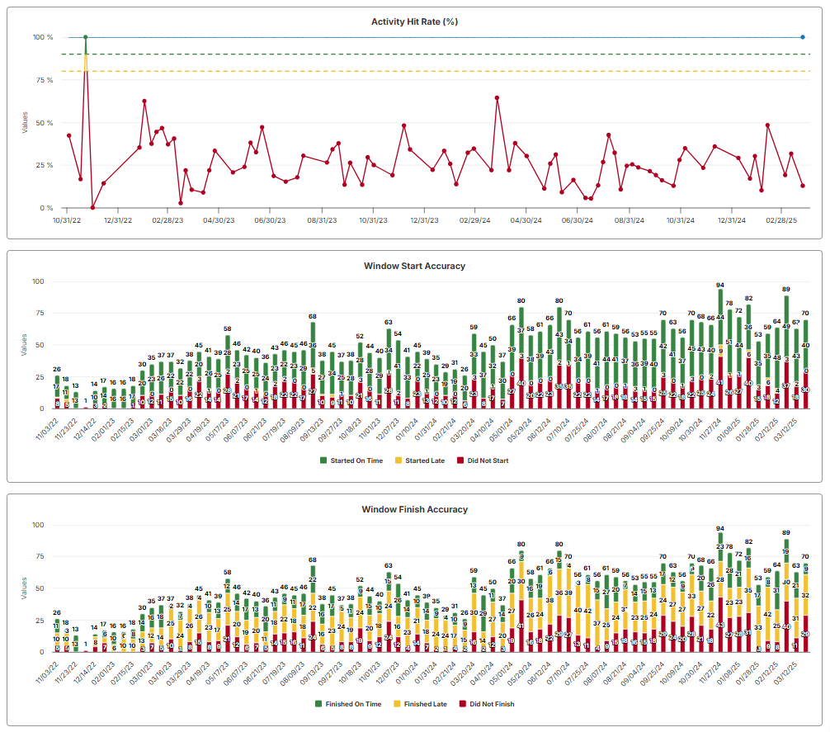
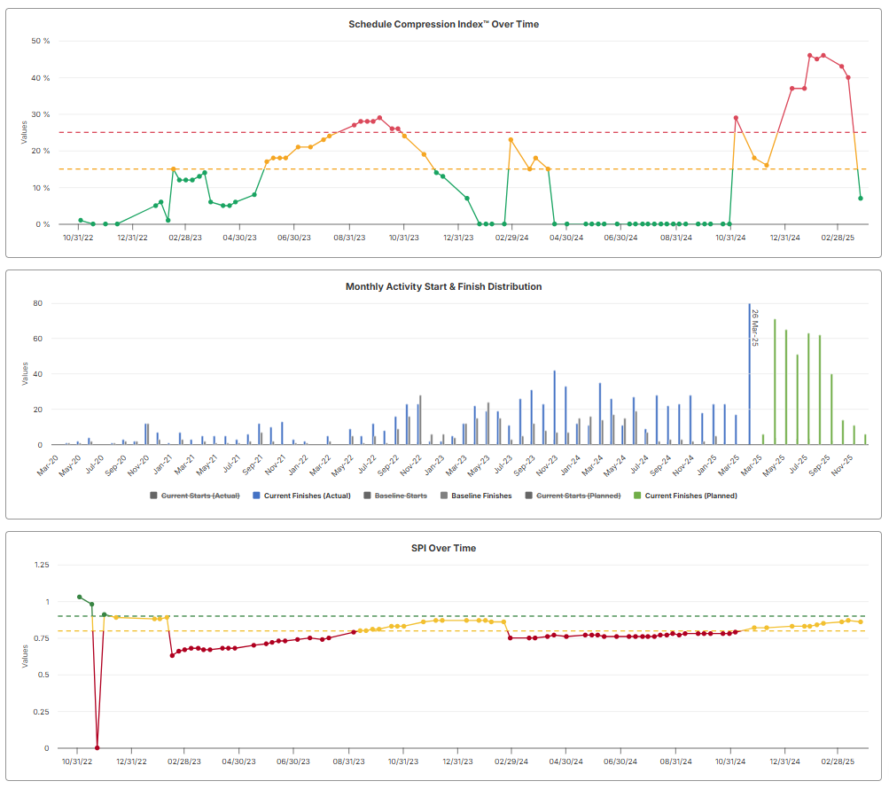

I have again included the Schedule Compliance Report in excel for your use. Please note: You will need to verify responsibility for the impacts. This report should be distributed to the Project Team each week, and reviewed in detail during the OAC. Please include the form with the meeting minutes and add language to the minutes stating all parties reviewed the Schedule Compliance Report in detail and acknowledge doing so. If they wish to make any adjustments, or contest any information included in the report they may do so by responding to the meeting minutes within 24 hours, or as defined by the contract.

I have included the procurement and progress update spreadsheets. Please use these to fill out all actual dates, and confirmed durations prior to each update. This will significantly reduce the time we spend updating each week to give us more time to work on recovery planning.

The most current XER file should be sent to Parco Consulting for their analysis one week before our meeting on February 19th.
Please let me know if you have any questions.
Thanks,

